Name of Student: Husam Ali Abdala Nour | PRN:25070122086
Semester: III | Year : AY 2026-27
Subject: Programming with Java
ASSIGNMENT No : 3
TITLE : Method Overloading and Static Members
Problem Statement
Develop a Java application demonstrating method overloading and the use of static variables, methods in class design.
Learning Objectives
To implement method overloading and use static variables and methods in Java programs.

Programme
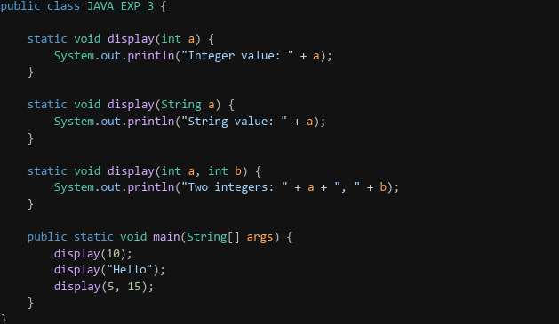
Output
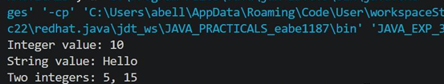

Conclusion
This assignment demonstrates how method overloading enables compile-time polymorphism by allowing multiple methods with the same name but different parameters. It also shows how static variables and methods belong to the class, enabling shared data and efficient memory usage in Java.

